CREATE TABLE O_RollCall (
student_id INT PRIMARY KEY,
student_name VARCHAR(100),
roll_date DATE,
status VARCHAR(20)
);

CREATE TABLE N_RollCall (
student_id INT PRIMARY KEY,
student_name VARCHAR(100),
roll_date DATE,
status VARCHAR(20)
);

INSERT INTO O_RollCall (student_id, student_name, roll_date, status) VALUES
(1, 'Alice', '2025-09-15', 'Present'),
(2, 'Bob', '2025-09-15', 'Absent'),
(3, 'Charlie', '2025-09-15', 'Present');

INSERT INTO N_RollCall (student_id, student_name, roll_date, status) VALUES
(2, 'Bob', '2025-09-15', 'Present'),
(3, 'Charlie', '2025-09-16', 'Absent'),
(4, 'Diana', '2025-09-15', 'Present');
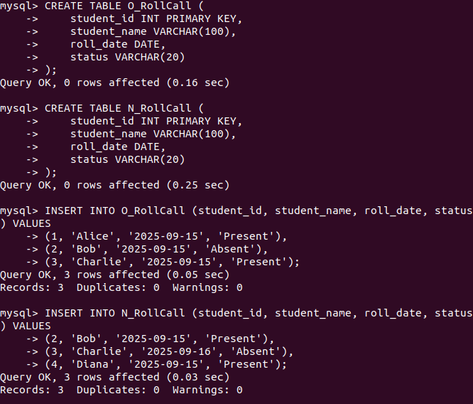

DELIMITER //

CREATE PROCEDURE Merge_RollCalls(IN roll_date_param DATE)
BEGIN

DECLARE v_id INT;
DECLARE v_name VARCHAR(100);
DECLARE v_date DATE;
DECLARE v_status VARCHAR(20);

DECLARE done INT DEFAULT FALSE;

DECLARE cur_rollcall CURSOR FOR
SELECT student_id, student_name, roll_date, status
FROM N_RollCall
WHERE roll_date = roll_date_param;

DECLARE CONTINUE HANDLER FOR NOT FOUND SET done = TRUE;

OPEN cur_rollcall;

read_loop: LOOP
FETCH cur_rollcall INTO v_id, v_name, v_date, v_status;

IF done THEN
LEAVE read_loop;
END IF;

IF NOT EXISTS (
SELECT 1 FROM O_RollCall
WHERE student_id = v_id AND roll_date = v_date
) THEN

INSERT INTO O_RollCall(student_id, student_name, roll_date, status)
VALUES (v_id, v_name, v_date, v_status);
END IF;
END LOOP;

CLOSE cur_rollcall;

END;
//
DELIMITER ;

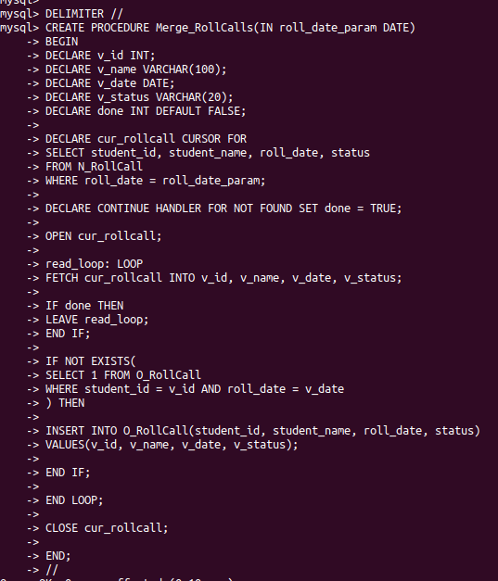

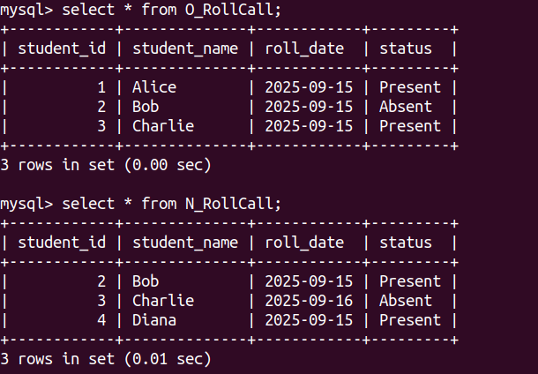

Calling procedure

CALL Merge_RollCalls(‘2025-09-15’);

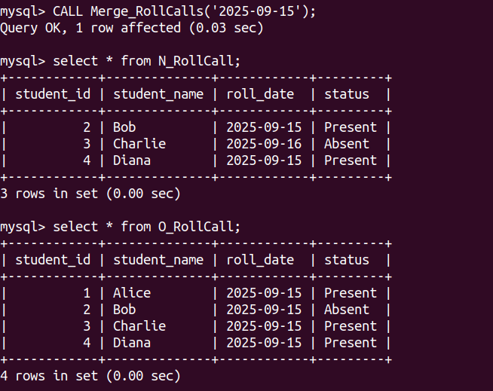

With comments

DELIMITER //
CREATE PROCEDURE Merge_RollCalls(IN roll_date_param DATE)
BEGIN
-- Declare variables for cursor
DECLARE v_id INT;
DECLARE v_name VARCHAR(100);
DECLARE v_date DATE;
DECLARE v_status VARCHAR(20);

DECLARE done INT DEFAULT FALSE;

-- Declare explicit parameterized cursor
DECLARE cur_rollcall CURSOR FOR
SELECT student_id, student_name, roll_date, status
FROM N_RollCall
WHERE roll_date = roll_date_param;

-- Handler for cursor end
DECLARE CONTINUE HANDLER FOR NOT FOUND SET done = TRUE;

-- Open the cursor
OPEN cur_rollcall;

-- Cursor FOR loop simulation
read_loop: LOOP
FETCH cur_rollcall INTO v_id, v_name, v_date, v_status;

IF done THEN
LEAVE read_loop;
END IF;

-- Check for existence in O_RollCall
IF NOT EXISTS (
SELECT 1 FROM O_RollCall
WHERE student_id = v_id AND roll_date = v_date
) THEN
-- Implicit cursor: insert new record
INSERT INTO O_RollCall(student_id, student_name, roll_date, status)
VALUES (v_id, v_name, v_date, v_status);
END IF;
END LOOP;

-- Close the cursor
CLOSE cur_rollcall;

END;
//DELIMITER ;

